

|  |
| --- |
| School of Computing  Faculty of Engineering |

Full Title of Project

Full Name of Author

Submitted in accordance with the requirements for the degree of  
<Name of Degree>

Session (e.g. 2014/2015)

The candidate confirms that the following have been submitted*:*

*<As an example>*

|  |  |  |
| --- | --- | --- |
| **Items** | **Format** | **Recipient(s) and Date** |
| *Deliverables 1, 2, 3* | *Report* | *SSO (xx/xx/xx)* |
| *Participant consent forms* | *Signed forms in envelop* | *SSO (xx/xx/xx)* |
| *Deliverable 4* | *Software codes or URL* | *Supervisor, assessor (xx/xx/xx)* |
| *Deliverable 5* | *User manuals* | *Client, supervisor (xx/xx/xx)* |

Type of Project: ____________________________________

The candidate confirms that the work submitted is their own and the appropriate credit has been given where reference has been made to the work of others.

I understand that failure to attribute material which is obtained from another source may be considered as plagiarism.

(Signature of student)

© <Year of Submission> The University of Leeds and <full name of candidate>

# Summary

*<Concise statement of the problem you intended to solve and main achievements (no more than one A4 page)>*

# Acknowledgements

*< Karim Djememe Brandon Bennet Vania This page should contain any acknowledgements to those who have assisted with your work. Where you have worked as part of a team, you should, where appropriate, reference to any contribution made by others to the project.*

*Note that it is not acceptable to solicit assistance on ‘proof reading’ which is defined as “the systematic checking and identification of errors in spelling, punctuation, grammar and sentence construction, formatting and layout in the text”; see* [*http://www.leeds.ac.uk/qat/documents/policy/Proof-reading-policy.pdf*](http://www.leeds.ac.uk/qat/documents/policy/Proof-reading-policy.pdf)*. >*

# Table of Contents

Summary iii

Acknowledgements iv

Table of Contents v

1 Introduction 1

1.1 Project Overview 1

1.1.1 Problem statement. 1

1.2 Minimum Requirements 2

1.3 Objectives 2

1.4 User Collaborative Agile Design Methodology 2

1.4.1 Agile Story Workshops 2

1.5 Schedule 3

2 Background Research 4

2.1 Developing For Android Or IOS 4

2.1.1 Android 5

2.1.2 IOS 5

2.3 Conclusion to OS choice for development 6

2.2 Programming Language For Development 6

2.2.1 Objective C 6

2.3 REST 7

2.3.1 Why Use REST? 7

2.3.2 REST Framework Jersey 7

2.5 Integrated Development Environment 8

2.5.1 XCode 8

2.5.2 Eclipse 8

2.6 Database Software 9

JDBC 2.6.1 9

3 Design 10

3.1 Gathering Requirements 10

3.2 Review of Similar Mobile Applications for Design Ideas 10

3.2.1 IPharmacy 10

3.2.2 NHS South of England Antibiotic Prescribing in the Community 12

3.2.3 Review of Ideas Gathered for Design 13

3.3 Low Fidelity Prototype ///////ADD PAPER DESIGN *SCANNER 13

3.3.1 Presentation of Low Fidelity Prototype. 14

3.4 Mobile Application Structure 15

3.5 REST Server Structure & Administration User Interface 15

3.6 Database Structure 15

4 Implementation 16

4.1 Iteration 1 16

4.1.1 User Interface 16

4.1.3 Drug and Pathogen Views 17

4.1.4 Calculator 19

4.1.5 Evaluation of First Iteration 20

4.2 Iteration 2 21

4.2.1 Using GData 21

4.3 Iteration 3 23

4.4 Iteration 4 23

Evaluation 25

.1 Results From User Testing 25

.2 Future Work 25

.3 Personal Reflection 25

.4 Client Reflection 25

.5 Dicussion on REST vs the Normal Way vs SOAP 25

Bibliography 26

Appendix A External Materials 28

A.1 First Iteration User Interface 28

A.2 Meeting Notes 29

A.2.1 Meeting 1 Introductions 29

A.2.2 Meeting 2 Refining Requirements 29

A.2.3 Meeting 3 Data structure 30

A.2.4 Meeting 4 Presentation of First Iteration 30

A.2.5 Meeting 5 Presentation of Second Iteration 30

A.2.6 Meeting 6 Presentation of Third Iteration 30

A.2.7 Meeting 7 Presentation of the forth iteration 31

A.3 Second Iteration User Interface 32

Appendix B Ethical Issues Addressed 36

B.1 Level 2 Heading 36

# 1 Introduction

The reason for this project is to create mobile applications for use by health care professionals to look up treatments for Lung infections. People with cystic fibrosis are vulnerable to lung infections that are usually harmless to healthy people. Cross-infection can be deadly to people with cystic fibrosis, this means they need extra care and need quick treatment to make sure they have a better quality of life (Cystic Fibrosis Trust, 2013). To treat these infections combinations of toxic antibiotics have to be used. Doctors can sometimes struggle to find information quickly about choosing the right antibiotics for a specific pathogen. The main aim of the mobile applications is to allow fast access of this information while working in hospitals where there may be no internet connection thus making it hard to get the information. The mobile application will update when a connection is present then will store this information on the device to be used even if there is no internet connection. This will enable doctors to have a quick reference guide on hand. This report will show how the application was made and justify design/technology choices.

## Project Overview

This project is to create a simple mobile application doctors can look up information about a particular drug or pathogen. The mobile application will use a RESTful web server that will deliver the data in XML. The server will be connected to a MySQL database in which drugs can be easily added and removed using a web browser based administration interface created with java servlets.

### 1.1.1 Problem statement.

The problem is bad internet connectivity in hospitals making it hard to for doctors to have quick access to information. This particular problem is the access to information on antibiotics to treat lung infections. There is a need for a quick reference guide on a mobile device that can be updated by an expert. The application needs to update when a connection is present but work offline. There needs to be an admin system to allow an expert to update the information on the mobile applications.

## 1.2 Minimum Requirements

## 1.3 Objectives

## 1.4 User Collaborative Agile Design Methodology

For the development process of the project and Agile methodology was followed. As the project has to be completed in quite a short duration of time the ability to provide working software at each stage of development. Constant interaction with the client is allows for changes during implementation at any time so new directions can be taken with little effort. This is advantageous as following this methodology gives the ability deliver something that the client can use even if there are unforeseen problems or large changes that affect the schedule of the project.

The main goals of this methodology are :

* Get feed back from client by continuously delivering working software in each of the iterations.
* Allow changes at any time during development.
* Work directly with the client face-to-face if possible to deliver the best possible product to the customer.
* Justifying design/development choices and following best practices to speed up development process. (The Agile Alliance, 2015)

### 1.4.1 Agile Story Workshops

Various techniques are used in Agile, such as Agile story workshops. A story workshop is meeting with developers and the client(s) where stories are created to explain what is needed for each feature. For example “As a user, I want to be able to see information about a drug at a glance. This includes; a name, brand names, dose, type of drug, interactions, side effects and various routes of administration for paediatric and adult patients.” This describes the feature in what information needs to be displayed for a drug. This is done for all users so example of a different user would be “As an admin user, I want to be able to add or remove the drugs that are displayed on the mobile app.”. This describes the feature of adding an administration interface to be able to be able to add and remove drugs. This allows the developer(s) and client(s) to prioritise the features easily by rating the importance of each story. The developer(s) then plan which features to be done in each iteration make sure at the end of each iteration that the software could be shipped if necessary. (Quotient Integrated Solutions, 2014).

For this project this technique was followed but with the use of storyboards as well. From the user stories, storyboards were created to show a visual process of how the user interface. This allowed the client to see how the features would look and if this is how it was imagined in the user stories. This speeds up development times as the storyboards can help confirm the designs of the basic user interface eliminating the risk of the user interface needing large changes that could affect the schedule of the project. This can be done quickly and simply on paper in preparation or during a meeting. Following this approach conforms to principle 10 of The Agile Alliance’s Principles of agile software “Simplicity--the art of maximizing the amount of work not done--is essential” (The Agile Alliance, 2015). As the work that would be created in constantly changing the user interface to suit the client’s imagination would be eliminated because it was already confirmed.

## 1.5 Schedule

# 2 Background Research

## 2.1 Developing For Android Or IOS

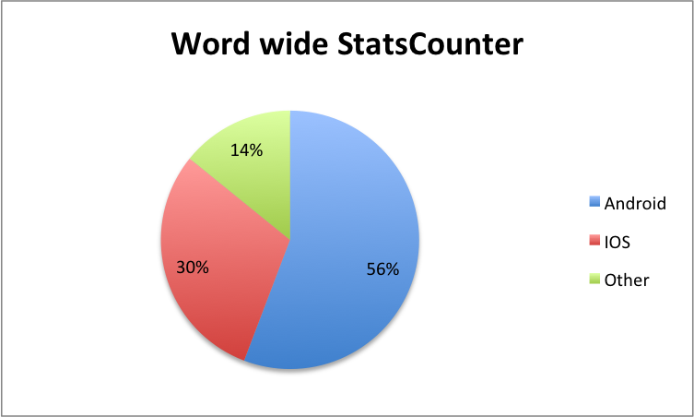The two most popular mobile operating systems are Android and IOS. There is debate on which is truly the most popular but mostly all sources agree these are the two market leaders. The two top companies for gathering data on the popularity of mobile operating systems are StatCounter and Net Market Share. Net Market Share gathers its statistics by measures total traffic and StatCounter measures daily unique users (Bott, 2014). Statistics for this year from; (Net Market Share, 2015), (StatsCounter, 2015a), are shown in **Figure 2.0.**

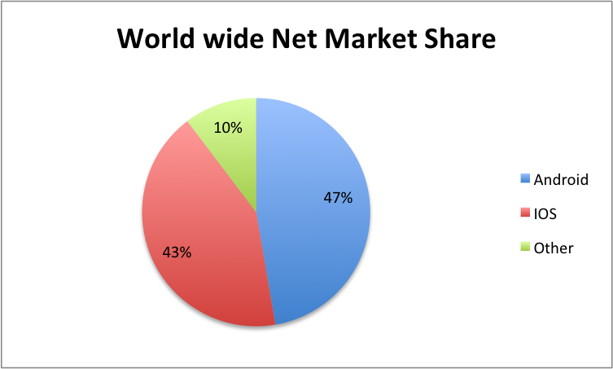**Figure 2.0** – Pie charts showing the market share in 2015 of mobile operating systems data taken from (Net Market Share, 2015) *left* which is measured by total traffic. (StatsCounter, 2015a) *right* measured by daily unique users. These charts were created in Excel using data from the sources.

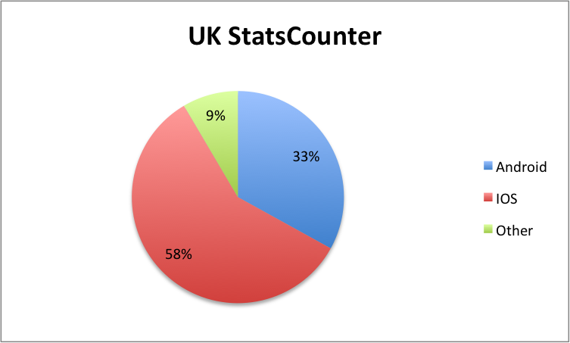

**Figure 2.1** – Pie chart created in Excel showing market share from (StatsCounter, 2015b) measured by daily unique users in the UK in 2015.

Although the two sources agree that Android is the dominant operating system world wide, when filtered for the UK as shown in **Figure 2.1** IOS the dominant mobile OS in the UK (StatsCounter, 2015b). Net Market Share does not offer region filtering for free so it is assumed that the statistics follow the same pattern.

### 2.1.1 Android

Android is claimed to be the most popular mobile operating system world wide and provides a very open market place to distribute apps (Android, 2015). Android has many devices in which its operating system runs on from various companies such as Samsung, HTC, Motorola, ASUS and many others. The devices created by these companies operate on many different screen sizes and versions of the operating systems. A download is available from Google Play’s support page that gives an A-Z list of all the devices that Android supports, the number of devices is approximately 8,725 (Google, 2015b). As there are a great deal of devices testing can be a long process when developing for Android.

Google Play is Android’s main source of mobile application distribution although Android does not restrict developers to publish Android applications on other application stores. To publish an application a registration fee of $25 is required this is a one time fee per account and allows developers to publish their applications on the Google Play store. Google allows Android applications to be uploaded by developers on to the Play Store in short time usually the same day as it was published (Google, 2015a). The applications are scanned automatically for malicious and poorly implemented software as they are uploaded to maintain quality applications on the application store (Mills, 2012). This is a major benefit to developers as the software can be released very quickly minimizing the gap between development and release lowering the cost of development especially for companies that hire many developers for a particular application.

### 2.1.2 IOS

The usage of IOS devices is prominent in the UK with over 50% of data traffic on IOS (StatsCounter, 2015a). In comparison to Android there are far fewer device variants on IOS, various versions of iPad, iPhone, iPod Touch in which under 20 devices run IOS 8.0. As there is such a small number of devices testing is far quicker as well as the there is an emulator for each device build into the IDE that Apple provides.

The Apple App store is the only place where applications can be downloaded to mobile devices. The development for IOS is much more restricted than Android. To publish an application to the App store an annual fee of $99 is required to enrol on the developer program. This then gives the developer a certificate to authorise the apps they develop. Once the application is developed it has to go through the review process. This takes an average of 8 days according to the crowd sourced site (Shiny Development, 2015) as of 14th of April. If the application is not rejected it then will be released on to the application store, although if it is rejected the entire review process has to be repeated once the issue is resolved (Apple, 2015a). In comparison to Android the release time can take much longer as if an app especially if some guidelines are missed during development. The reason for Apple doing this is to ensure the quality of the applications on its App store to keep the companies good reputation. This can be frustrating to developers and seriously impact development times but ensures only higher quality applications can be released.

### 2.3 Conclusion to OS choice for development

The choice of operating system to develop for is IOS for the following reasons:

* The client wanted the development to be in IOS. It is the clients opinion that is IOS the most popular among the student doctors in Leeds University.
* IOS is assumed to be the most popular in the UK for mobile devices as discussed above.
* Testing an Android application may take longer than IOS due to the amount of variation between the many devices that use Android. Due to the limited time of the project, if Android was chosen the application may not be compatible with some devices as they cannot all be tested within the time frame. IOS however can has very few devices and the XCode IDE has emulator for all the most recent devices.
* Although deploying the application on the App store may take longer than Android, the App Store review process will help identify any unforeseen bugs in the application and when it gets through it’s a sign that this application is of high quality.

## 2.2 Programming Language For Development

### 2.2.1 Objective C

The chosen language for the mobile application is Objective C this is because it is the native language for Apple’s operating systems and is has a large supported community. This means it has substantial examples and libraries to help the development of this project.

Swift was an alternative but as it is still very new there could be issues with constant updates and changes causing features to become outdated or cause bugs (Eid, 2014). Also because it is so new there may not be as many examples to learn the code as compared with Objective C. Although this language is simpler syntactically compared to Objective C, Swift still uses Objective C libraries. This could make the code difficult to understand if written in two different languages.

C++/C could have also been used but the code would have needed some Objective C wrappers and converters for the application to run on IOS. This would of meant mixing languages making the code less readable and verbose.

## 2.3 REST

Representational state transfer, also known as “REST” is an architectural style of developing a distributed system which was first shown in a paper by Roy Fielding. As REST is style not a standard, there is no W3C recommendation for it and it is simple enough to be used for a variety of approaches. (Vogel, 2014) (Elkstein, 2008)

### 2.3.1 Why Use REST?

Having a RESTful layer means that any application from any operating system can communicate with the server meaning that if needed other developers can look at the API and create their own app that displays the data the way they want it. REST is stateless meaning doesn’t rely on traditional methods of communicating with a server as it doesn’t create a session of persistent connections, it just uses HTTP perform operations on a web service. The benefit of this is speed and scalability as the application can just use a URI to get the exact data without having to maintain a session. Another advantage is loose coupling which means it can be platform independent as HTTP can communicate with mostly all devices that can connect to the internet. The client wants this system to be used after the project has been completed. Developing the server using REST will allow the data to be transferred to the app as it does not need to know anything about the server other than the URI for it to understand the data. Any application with an internet connection and XML handling can get and understand this data. If the app needs changing due to updates released by the operating system it can be completely redesigned without having to do anything to the server. This data will be in XML format so any platform can use the data to display the information.

### 2.3.2 REST Framework Jersey

To make the development of the RESTful server easier a framework called Jersey was used. There are many different frameworks that can be used to develop REST services but I have had experience with Jersey and the IDE Eclipse during my degree. Due to the short time of the project the decision to use a more familiar framework will help shorten development and research time. Jersey is also recommended by IMB to create REST services with the use of Apache Tomcat for the container of the application (IMB, 2009).

Jersey also has some useful features built in such JAXB which converts nested Java classes to be converted into XML using simple notation. This a very useful library as the XML generation and input can be done automatically with a small amount of code. As this method has been tried and tested it reduces the risk of bugs in comparison to implementing the marshalling from scratch.

Jersey is designed to work with the Apache Web container Tomcat. The need for a web container is to run the web application and to handle the dynamic webpages as the server itself can only return static pages. Apache Tomcat will be used to precompile/validate the web application and offers a GUI for to do this simply. This will speed up the process for testing different versions of the server to make sure everything is working properly.

## 2.5 Integrated Development Environment

### 2.5.1 XCode

The chosen IDE to develop the mobile application is XCode as it provides all the necessary tools and features needed to create mobile applications in IOS. XCode is what Apple recommends to develop IOS applications and Apple includes a great deal of documentation of how to develop applications for IOS in XCode. This IDE can understand languages of C/C++/Obective C and Swift and includes emulators for the most popular mobile devices to test the applications. XCode also includes build in Git Hub version control which can control the changes to the project (Apple, 2015b). XCode also has a direct link to the certificate control for the Apple App Store so this will enable the project to be deployed easily when run with a developers account. This will make it easier for the client to get it on to the application store at the end of the project.

### 2.5.2 Eclipse

The chosen IDE to develop the server is Eclipse. Eclipse has the ability add different plugins internally in the IDE so it is very easy to customise for development of a particular application. The Eclipse IDE is also used in many tutorials on how to develop web applications for REST and what was used in the Distributed Systems module Lab sessions of the IT degree. This choice will help shorten the time having to familiarise with interfaces/features and increase time on actual development.

## 2.6 Database Software

One of the requirements for the project is to have a database to store all the data on the drugs and pathogens. The client already has a database with drug data but nothing on the pathogens. Thus will need some software to be able to open and edit the database to add pathogens. WAMP was first chosen as it has the ability to open many different types of SQL which would be useful for opening the clients database as it was not known what format it would be in.

Later in the project there were problems with the clients database which is discussed later in section 4.3. This required creation of a new database but this proved to be quite difficult in using WAMP’s phpMyAdmin web based interface. This was because of the amount of fields on each webpage and it was difficult to find how to create relationships between tables. It was decided to select a new software tool that could speed up the process.

MySQL Workbench was chosen because it has a simple interface to create tables in a database. It allows the user to create visual schemas which allowed tables and relationships to be drawn up quickly. From the visual schema the SQL is automatically generated speeding up the development process.

### JDBC 2.6.1

To be able to connect the server to the database it was decided to use the Java Database connectivity (JDBC) API. It allows the server to send SQL queries to the database to retrieve data to be used on the server and manipulate the database. To be able to do this the API needs to use a driver for the particular type of SQL used by the database the “mysql-connector-java-3.1.14” driver will be used as this is the most recent release and MySQL is the chosen database language.

# 3 Design

This section discusses how the plan for the application was constructed. This includes user interface design, structure of the mobile application and server and how the requirements were gathered.

## 3.1 Gathering Requirements

To gather the requirements effectively a series of face to face meetings were organised with the client. This is crucial to the agile methodology as it is described as the most efficient and effective way of conveying information (The Agile Alliance, 2015). As shown in **A.2** the meetings were used to discuss what was needed in the application and gather feedback on progress.

As this mobile application is to be used by doctors looking for information on drugs and pathogens to do with Cystic Fibrosis. The first meetings were very crucial to the project to get the most feedback possible about what was wanted from the application. The challenge was that the medical terminology and types of information to be stored on the application had to be understood to ensure they were displayed correctly. Having meetings with an expert in this area made sure that anything not clear in the requirements in the project proposal could be explained as well as complicated medical terminology. Brief notes of the meetings can be found in **A.2.**

To help clarify what features will be needed for the mobile application and server, user story workshops as were used as discussed in **1.4.1.** This technique was used throughout the project helped clarify exactly what features were going to be needed for the application and server. The most important stories were then organised into general deliverables for each iteration this is shown in **A.5.** Creating clear objectives from the user stories helped plan out the project.

Constructing the user interface involved reviewing other mobile application that offer medical information. Reviewing other user interfaces highlighted good features that could be used in the project as well as showing the client possible ways to display the information. The review helped gather requirements for the user interface and allowed the client to convey features that would be beneficial for the mobile application.

## 3.2 Review of Similar Mobile Applications for Design Ideas

To help the development of ideas for the user interface other similar mobile applications were analysed. The main aspects of the user interfaces analysed were to do with how the information was displayed about a drug or disease and how the navigation operated.

### 3.2.1 IPharmacy

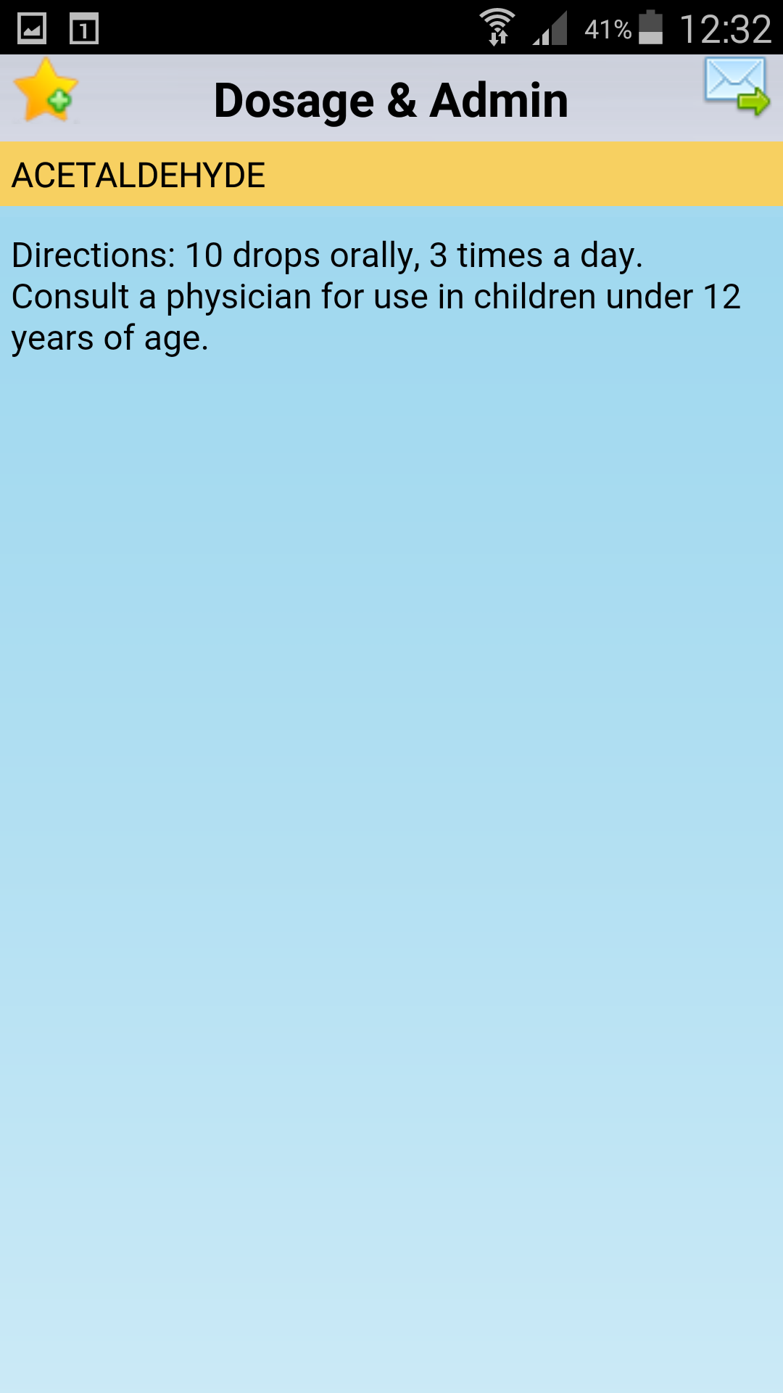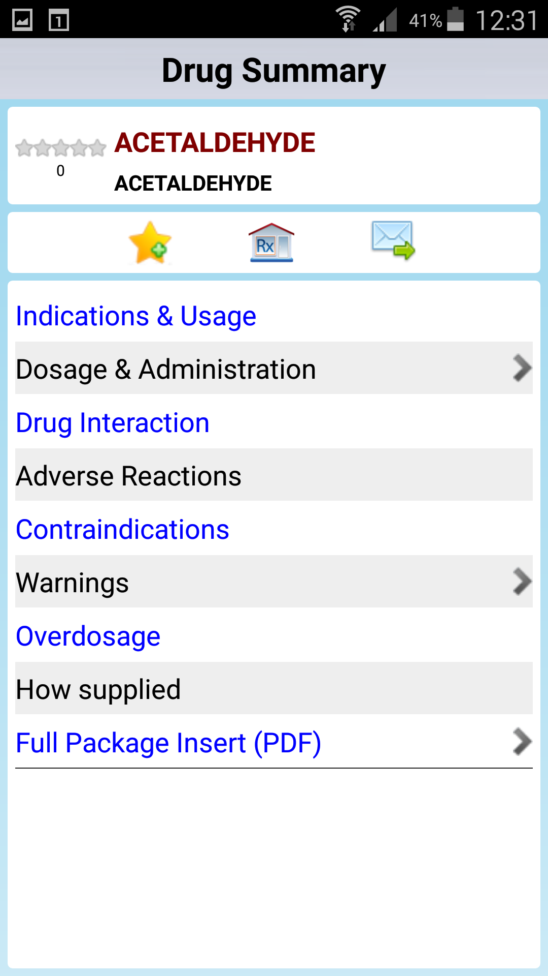One of the applications reviewed was IPharmacy this application is available on the Play Store for Android.

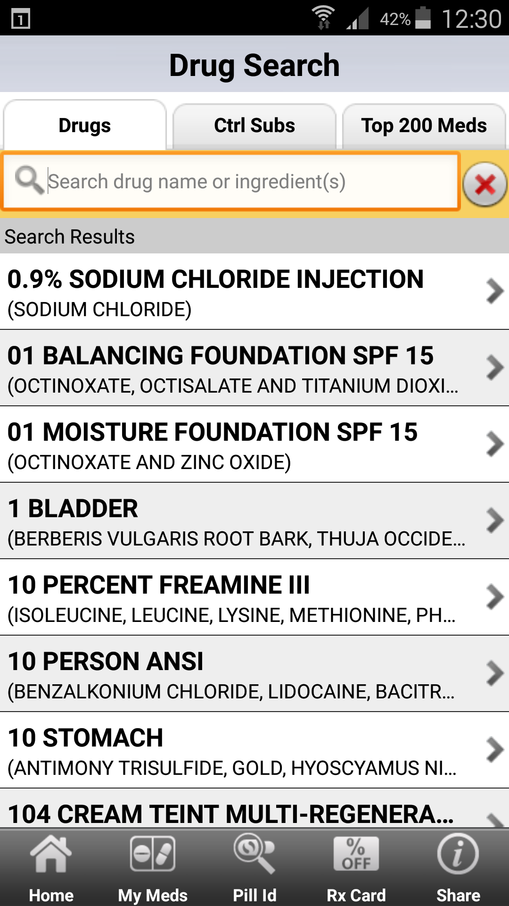

**Figure 3.0** –Screen shots of IPharmacy Mobile application (MedConnections, 2014)

This application offers many features such as; finding pharmacies, reminders when to take medication along with many others but these were not needed in the application for this project so only the drug search feature was reviewed. Additionally this application does not store any information on the device and relies on an internet connection to work. The first view seen on the drug search feature in **Figure 3.0** is a simple table showing many different drugs and a search bar to find a particular drug. This could be a great way of allowing a user to select a drug simply from a table. Although IPharmacy’s table is confusing as there is a lot of information in each cell and some of the information doesn’t even fit in the cell to avoid user confusion the data shown in the cells should be as short as possible. The use of a bar at the bottom to navigate to other areas of the application is also a useful feature.

The drug summary view in the middle of **Figure 3.0** shows what happens when a drug is selected. It displays another table of categories of information about a drug. This table was confusing as it was not clear why some of the text was in blue and some in black. There was also no clear way of navigating back to the table without having to push the back button on the phone rather than using in app navigation. The user interface for the projects mobile application should avoid assuming every user knows exactly how the phone operating system works and provide clear in app navigation. Also if information is not available it should be clearly disabled or not present. The interface on IPharmacy only shows a small arrow on the side and if not present it means there is no data for that category, that wasn’t clear during the first use.

The third view shows in **Figure 3.0** when dosage and administration is selected from the categories table. This view seemed unnecessary to have such a small amount of information taking up an entire view. Again it had no obvious in app navigation and relied on the users knowledge of the operating system to navigate.

On review of this application it was clear the features that worked well like storing the names of the drugs in a table and allowing a user to select them to see more information about a drug. A feature similar to this will be used for the first low fidelity prototype. However the display of the information and navigation of the application was not user friendly in my opinion. As each category can only been seen one at a time it greatly increases the cognitive load of a user as they will have to remember everything that was shown in the other categories to be able to have a clear understanding of the drug. This will be avoided for the first design as I want the user to be able to see all the information at a glance and not have to navigate through many views to get the information needed. Also the users need to know what information is available such as routes of administration at a glance so if it not present it should be disabled or not visible.

### 3.2.2 NHS South of England Antibiotic Prescribing in the Community

This application was more focused on treating particular illnesses but still had some valuable information about drugs. **Figure 3.1** shows the use of the app when looking for drugs to treat “Acute Bronchitis”. This application is very colourful and easy to navigate as seen in each view there is a clear back button to go the previous view. Although there is a back button on the first view that just closes the application.

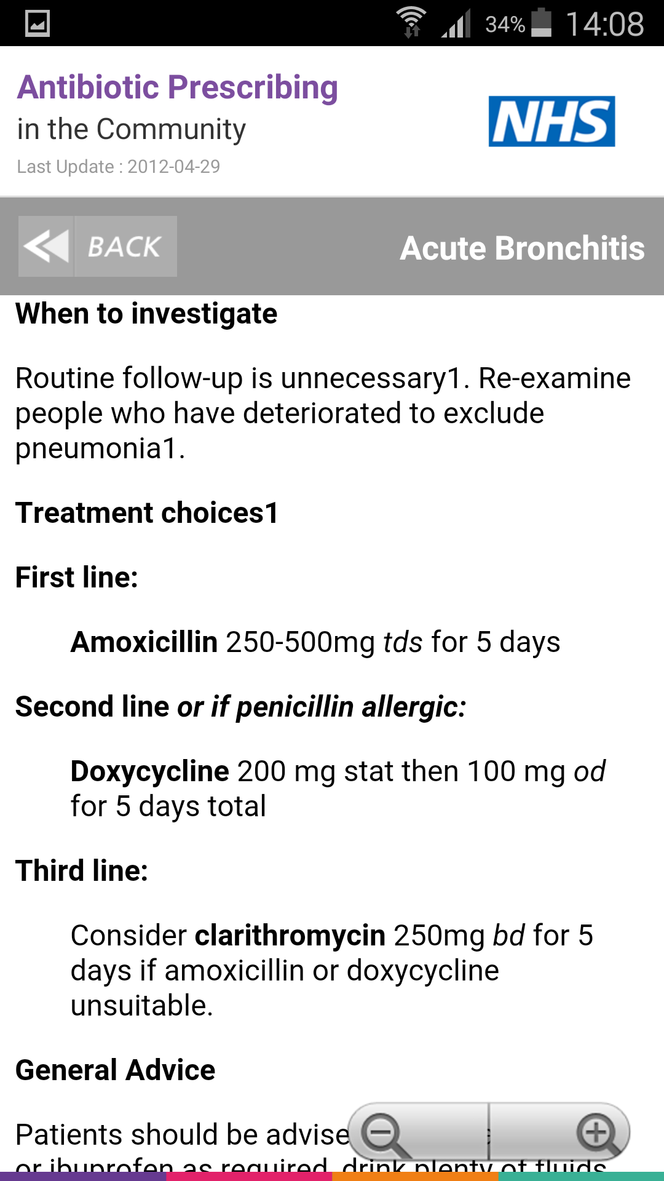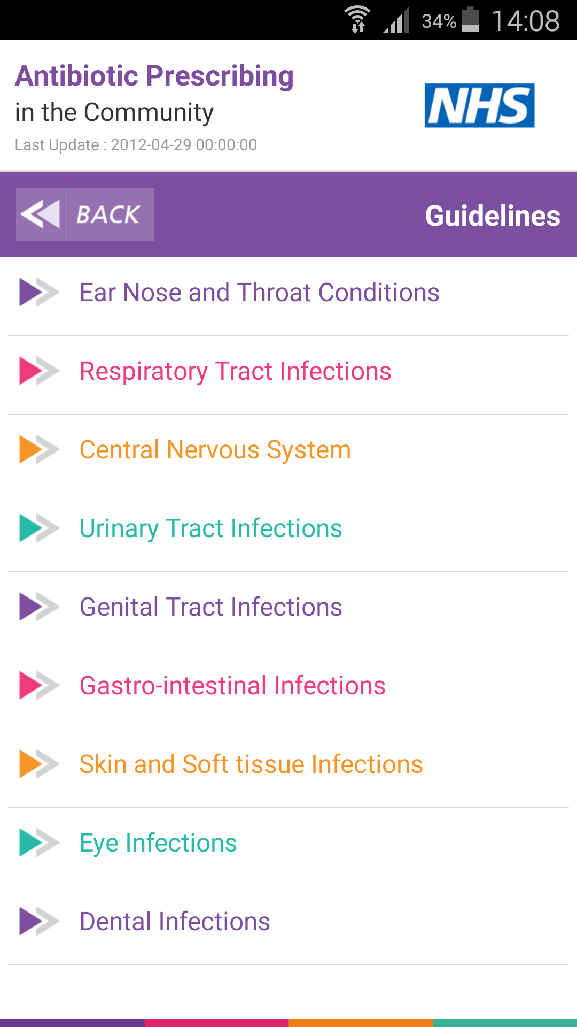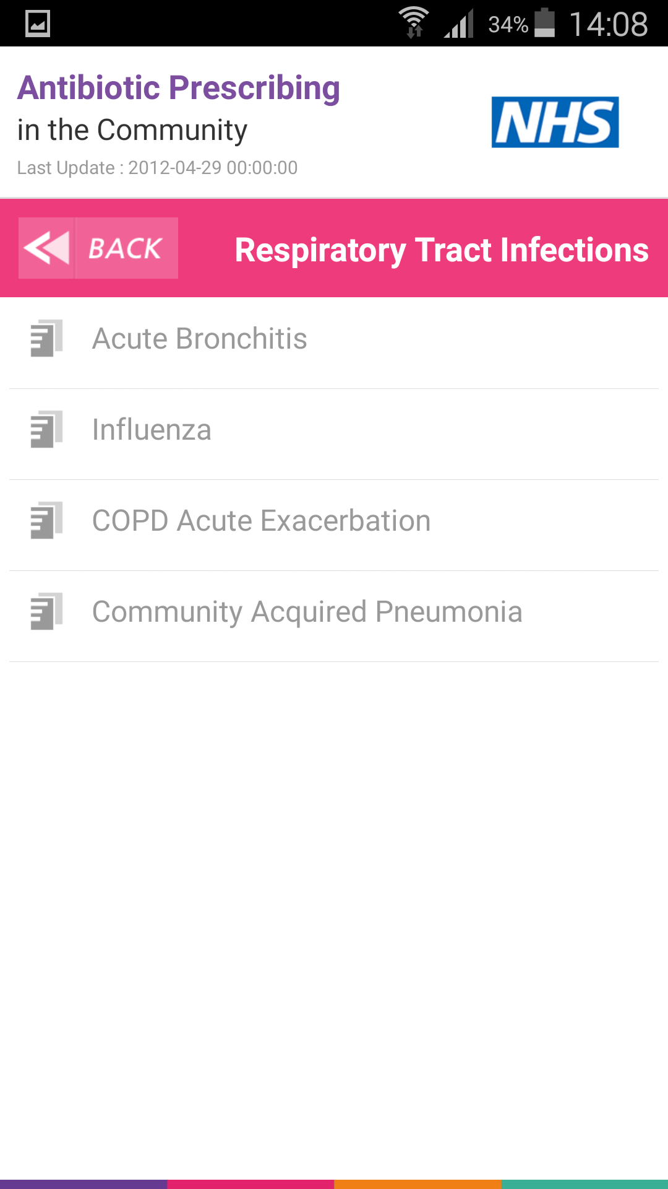This application was more focused on treating particular illnesses but still had some valuable information about drugs. **Figure 3.1** shows the use of the app when looking for drugs to treat “Acute Bronchitis”. This application is very colourful and easy to navigate as seen in each view there is a clear back button to go the previous view. Although there is a back button on the first view that just closes the application.

**Figure 3.1** – Screen shots of NHS South of England Antibiotic Prescribing in the Community mobile application (Blue Frontier, 2013).

The first view in **Figure 3.1** is similar to the IPharmacy application in where all the names are stored in a table. The NHS application however lists categories of illnesses. Again this is a very efficient way of allowing a user the information they want to see. The use of colour seems to have no reason other than to make the application look atheistically pleasing. If the information was colour coded that would be a useful feature to add to the design of the project mobile application.

The second view in **Figure 3.1** is another table but the arrow icon has been replaced to a document icon. Again the use of a table is useful to allow simple navigation for the user.

The third view in **Figure 3.1** is a display of lots of information do with “Acute Bronchitis” and is formatted like a document. This method of displaying the information is quite simple with no clear separation of information other than spacing and titles. The ability to see all the information at once is great but for the project design it would be best to help separate the information to make it more clear to the user. Also not all drugs will need every field so the ability to seamlessly remove or disable sections rather than parts of a document will allow users to notice easily what information is available for each drug.

On review of this application it had a simple navigation and colourful look and feel which is aesthetically pleasing to the user. The use of tables to show what information is available is definitely a must have feature for this type of application and should be considered for the first design of the project. The use of having all the information visible is a great for the user to see at a glance but should be organised in such a way that is obvious to the user and does not require a lot of scrolling.

### 3.2.3 Review of Ideas Gathered for Design

The main user interface ideas gathered from the review of two similar mobile applications are:

* The first views should include a table of drugs and a table pathogens listed by name in each view navigated by tabs as this is a simple but effective method of navigation.
* The detail view for each must be segmented in such a way to display the information at a glance and allow for users to see what information is available quickly.
* The use of colours could be used to colour code importance of drugs or pathogens.
* Minimize the amount of navigation it takes to find certain information to lessen the cognitive load of the user. This is to avoid navigation like the IPharmacy where only parts of information could be viewed at time.
* Allow in application navigation for inexperienced users. This is because it can be confusing to users unfamiliar with the operating system. For example if a user is used to Android devices which have a back button they can use the back button provide on the phone to navigate. But if they are used to IOS which does not have back button only a home button this may be confusing to the user if there are no obvious indicators on how to use the application navigation.

## 3.3 Low Fidelity Prototype ///////ADD PAPER DESIGN *SCANNER

Once the minimum requirements had been gathered and the low fidelity prototype could be created. There are many methods of creating such a prototype such as; paper, post it notes, white boards and online mock-up tools. For this project a combination of paper and white board prototyping was used to create the first design.

The reason for using this method is because it is a quick and cheap way to create a design in comparison to using a online tool to create a prototype. Using a online prototyping tool requires a workstation and the creation of the design can be quite slow as it usually involves interacting with a user interface. Paper prototyping however, can be done anywhere and the only tools needed are some paper and a pen or pencil. The paper method may not be as neat and digitally shared easily but the advantages of the speed interactivity during meetings over come the disadvantages.

The white board method is the one interactive during meetings out especially when combined with post it notes as many people can interact at the same time editing the design easily by adding or rubbing parts out. The disadvantage of using the whiteboard is storage of the ideas created as usually it cannot be taken physically from the room it is installed and it can be difficult to keep neat. But using a camera to document what was done can overcome this disadvantage.

For this project as the client cannot constantly interact with the design to suggest ideas of what is expected due to other responsibilities the paper prototype was created before a scheduled meeting. This was to get feedback on the design before the development process began as it is much easier to make large changes during the design phase before development. The paper prototype is shown in A?????? By using the paper prototype to convey the initial design idea the client was shown the design in **A2.2 Meeting 2.** This allowed ideas to be discussed on what the user interface would look like. Changes were made on the paper prototype and new features were discussed using the white board method.

### 3.3.1 Presentation of Low Fidelity Prototype.

During the meeting the main views were praised that the of splitting the pathogens and drugs into tables was a good feature. The detail views were discussed as having to much information in one view and should be segmented more. I suggested in having toggle buttons which would fill certain fields depending on the combination rather than many views to navigate through. This was agreed to be the best decision in displaying the information about the drugs. The use of colour coded buttons to navigate to different information about certain pathogens in the drug detail view was argued as complicating the user interface and should be one button that displayed all the pathogens related to that particular drug in a new table view. The pathogen table colour code was discussed as it may be quite difficult to develop in the short time frame as the data for the pathogens doesn’t exist in the clients database and creating a colour code might be out of the scope of this project. The tables will only show the names of the drugs and pathogens in the high fidelity prototype.

During the meeting a new feature was added to the low fidelity prototype where there could be a list of drugs associated with each pathogen which could be selected and compared to see if there were any interactions between them.

## 3.4 Mobile Application Structure

IOS applications are based on a model-view-controller architecture. This allow applications to be split into different parts for development (Apple, 2014). **Figure 3.2** shows what parts of the application are in each category.

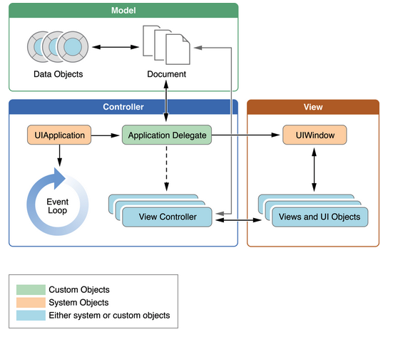

**Figure 3.2** – Figure from IOS Developer library showing the architecture of a IOS application (Apple, 2014).

### 3.4.1 The Model

The model is where the data is stored for the application so in the case of the project it will be an XML file that has been parsed from the server. The XML file will then be converted into objects to be used by the application.

Planning the structure for the XML file required an document object model tree (DOM tree) to be implemented. Creating the diagram was a method to get confirmation from the client that the all the information held by a drug or pathogen was correct. Furthermore it was used to help implement the objects for the IOS and Java server application. For further detail view **A.6**

### 3.4.2 The Controller

The view controller is where the user interactions are handled and where the functionality of the application is created. This part of the architecture will handle button interactions and parse the data from the model to the user interface to be viewed by the user. For example the objects created from the XML file would be parsed to the fields or tables in this part of the application. As seen in **Figure 3.2** the controller category as many components.

#### 3.4.2.1 UIApplication Controller, Event Loop and Application Delegate

These parts of the controller handle the communication with the operating system. The Application Delegate is described by (Apple, 2014) as “the heart of your custom code” and is required for every IOS application to run. It handles initialization, state transitions and application events. The communication with the server and storage of the information will be implemented in the Application Delegate as this is the first method that can run code created by the developer.

The event loop will notify the UIApplication contrller of all the user interactions with the device. For example if the user taps or rotates the screen the event loop will log this event and parse it to the UIApplication controller to do something with that event. The event loop will also give notifications of events of the operating system. A request from the operating system could notify the application to move to the background, which then will call state tranistion methods implemented in the Application Delegate. “applicationWillResignActive:” is one of these state transition methods which controls how the application behaves when it is about to enter the background (Apple, 2014). For example a phone call which will notify the application to move to the background. If the application was a game progress would be saved at this point to make sure the users progress was not lost, as well as making sure it lowers its resource consumption to avoid the operating system forcing it to close to free up resources for the phone call.

The mobile application for the project only displays data from an already saved file and won’t use a lot of the phones resources. Meaning there is no reason to implement these extra functions to handle events such as phone calls. The operating system will handle basic transitions automatically such as returning the user to the same view after the phone call has ended. The reason for documenting these features is if the mobile application requires more functionality after the project it may become more resource intensive and need event handling.

### 3.4.3 The View

The view is what the user can see of the application when using it on the device. The user does not know of the model or controller they can only interact with the view. This part of the application is the user interface which will be created in the Interface Builder using XCode.

### 3.4.4 The Design of The Mobile Application Structure

Planning was needed to be able to be able to implement the mobile application in an efficient way. UML is a language to visually that can be used to display the modelling of computer systems (Bell, 2003). Many types of diagrams can be created using UML. One such diagram is the activity diagrams which can be used to demonstrate the flow of operation in software. By using a visual planning tool, it can help organise the development and show how the design process of the application. **Figure 3.3** is the basic activity diagram for the mobile application and shows the flow between the view controllers and the user interface. ////HERE 27/04



**Figure 3.3** – Simple activity diagram of the mobile application

## 3.5 REST Server Structure & Administration User Interface

Methods to implement server return html,xml, delete, add, EDIT?

## 3.6 Database Structure

# 4 Implementation

The following segment of the report describes how the mobile application, server and database were implemented. The implementation section will give information on process of development to solve the project problem. The agile methodology is used for this project thus the implementation section is split into different iterations. At the end of each iteration a demonstration of the working software is given with an evaluation of work done during that iteration. This was done to simulate the part of the agile methodology “Deliver working software frequently, from a couple of weeks to a couple of months, with a preference to the shorter timescale” (The Agile Alliance, 2015).

## 4.1 Iteration 1

### 4.1.1 User Interface

The aim of this iteration was implement a working prototype of the mobile application. The first stage involved creating the user interface in the Interface Builder in the XCode IDE. The reason for using the interface builder GUI tool rather than developing the user interface programmatically is that it creates a storyboard of how the containers interact with each other as seen in Figure 4.1.2 This a valuable tool to be able to show the client as the flow of the program can be understood without knowledge of the source code. This allows the client to request interface changes and see the effect of the change before actually having to compile and run the code for each change, saving time in development and getting quality feedback during demonstrations.

Storyboards were created on paper from the user stories during the design phase so the process was quite simple and fast as XCode provides a simple interface to drag and drop components similar to those drawn in the user story created storyboards as shown in **figure 4.0**.

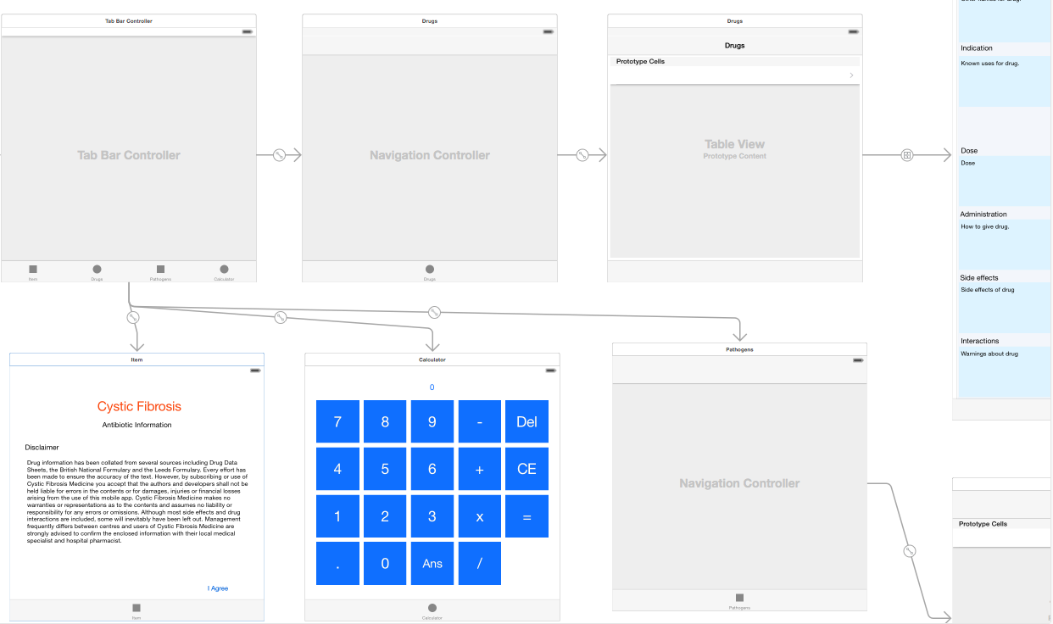

**Figure 4.0** – Storyboard of mobile application in Xcode

The main challenge of the user interface construction was getting it to resize dynamically for different screen sizes that are available for IOS. This is done by allowing all the objects to resize with the screen size but adding constraints to each of the objects inside the container to make the UI the. An example of a constraint is to make sure an object is always has a distance of 5 pixels to the right and of the container no matter how much they are stretched. This will allow for example a text area to resize to match the screen size to but always keep it centred. This is challenging because constraints can interact and override each other. When dealing with many constraints this can get very confusing into why a particular object is not behaving as it should when it is resized. XCode provides a feature “Resolve Auto Layout Issues” to help resolve this where it will fill in all the constraints that are needed to make the look like it does on the storyboard. Although this feature is very good at setting the positions the resizing is still an issue and needs other constraints such as keeping all the buttons on the calculator the same height and width ratio which have to be added manually.

The next step in the first iteration was to create the objects for the information on drugs and pathogens to be parsed to the UI. From the fields decided upon in the initial meetings the objects could be created to suit the output displayed on the user interface. The main challenge of creating the objects was understanding the medical terminology into how each variable should be stored in the object. For example would the dose need to be a description or measurement (string or integer). Once a drug object and a pathogen object were created the view controllers could now be implemented.

### 4.1.3 Drug and Pathogen Controllers

The objects are displayed in tables, drugs and pathogens each with a view controller to manage the operation of the user interface. The reason for using the built table components rather than use a customized UI component was to allow users familiar with IOS to be able to intuitively use the navigation of the app. The main view controllers are handled by a tab Each cell of the table links to a detailed view of the object displaying all the information about a particular drug or pathogen. This required the method of parsing data between view controllers based on what was selected in the previous one. IOS uses a method called prepareForSegue to do this.

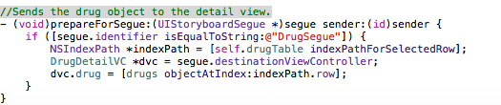

**Figure 4.1** – Segue parsing a drug object from the drug table to drug detail view controller.

The method in **Figure 4.1** looks for a segue created in the Storyboard then parses the object selected in the table to the detail view controller to be displayed. This also creates simple navigation for the user as to be able to use a segue the view controller has to be embedded into a navigation controller which automatically creates navigation buttons for the user to go back to the table as seen at the top of **A.1.2**. This is also how the pathogen object is parsed to the pathogen detail view **A.1.4**.

To clarify what information is available about a particular drug a segmented navigation bar is displayed showing the routes of administration available. This is shown in **A.1.2** as the blue bar near the top of the screen. If the drug does not have certain routes of administration the area is greyed out and is unable to be selected. This allows users to see how this drug can be administered at a glance and tap on a particular route to get more information about how to use the drug. This segmented bar was challenging to implement as the information on the view has to change when a selection is made. This required creating a function in which it read the data of the selected object to disable the parts of the bar so routes of administration that were not present could not be selected and shown they don’t exist to the user. An example of this is shown in the code **Figure 4.2.**

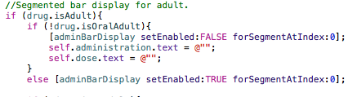

**Figure 4.2** – Segmented bar change if drug contains adult oral information.

The code checks if there is adult information then checks all the routes of administration for an adult. If a route is not found for example “oral for adults” then that segment of the bar is disabled and the text fields are cleared to avoid displaying any previous data. It was implemented in this way to help the users find the information they were looking for more intuitively rather than having to look at each text field to see if the information was present.

Once the segment bar only has the correct routes of administration available a function is needed to change the data in each text field when selected. An example is shown below in **Figure 4.3** for the adult oral selection.

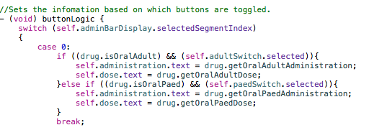

**Figure 4.3** – Text fields change on oral selection when adult or paediatric button is toggled.

The use of a switch statement is used to find which index of the segment is selected. The oral case checks that both the adult button has been selected and if the drug contains adult oral information to display the correct information. If the adult button has not been toggled then the paediatric button is checked to retrieve the paediatric information. This function is needed to make sure the correct data is displayed when certain combinations of buttons are toggled. This allows the user to access all the different administrations and doses on a single view along with all the other information, such as side effects, with out having to switch tabs lowering the cognitive load of the user.

### 4.1.4 Calculator

The design of the calculator is to give a way of answering simple left to right arithmetic and doesn’t include order of operations. The reason for not having order of operations is because the use of this calculator is just for simple dose calculations and there was no need to spend extra time creating an advanced calculator. The main challenge of the calculator was to make it simple to use. It was decided to allow more than one operation at a time which added to the complexity of the development but created a better experience for the user. For example “5+6-7” would be displayed then the answer would show “4” instead of having two operations “5+6 =11” then “11-7=4”. The solution to this problem was to create an array that stored all button presses and then concatenate the numbers. Then to create a new array that stored the concatenated numbers and operations and calculate the answer working through that array. This is explained in the code comments, see “CalculatorVC.m” for further information.

### 4.1.5 Evaluation of First Iteration

To evaluate the mobile application a demonstration was given to the client and supervisor of the project, notes shown in **A.2.4**. To do this a drug and pathogen object were created filled with test data that just showed what each field would represent. Three drugs and three pathogens were filled with data and displayed on the app. The client was then walked through each stage of the application and shown how the navigation worked and how it was similar to the low fidelity prototype. This was done to get feedback on the amount of data displayed, the look and feel of the user interface and if the application was useful at its present state.

The results from the demonstration were positive but some changes were needed for the next iteration. One suggestion was with the user interface for Drug Detail View as seen in **A.1.2** where both adult and paediatric are shown highlighted, the client suggested that it wasn’t obvious when you had selected the adult or paediatric information. This is critical because if a doctor prescribes an adult dose to a paediatric the drug can cause harm to the patient. So this would need to be changed for the next iteration such as making of the routes of administration bar smaller and making the adult and paediatric buttons larger and bordered.

Another criticism was with the fields displayed on the Drug Detail View as seen in **A.1.2**. There were some titles that needed to be changed to make the application more suited to the medical field such as “Treatment for” needed to be changed to “Indications”. The ordering was also discussed as doctors look at some fields more often than others so they need to be closer to the top. The field for the dose was misunderstood during the design phase and was thought to be just a number and a unit but a does also needs a description thus needing its own text area. A feature was suggested to be able to see only the pathogens associated with each drug that could be added in a later iteration.

The Pathogen Detail View **A.1.4** was also discussed. It was originally agreed that the pathogen object was going to have a list of first line and a list of second line drugs. But the client decided this was not the best route to take upon seeing it on the user interface as it was feared that it may cause arguments among doctors who would argue some drugs are better than others. So for the next iteration will only show first line drugs would be shown but would include all of the drugs that were affective on the particular pathogen.

The simple calculator was tested during the demonstration to see if was easy to use and gave the correct answers. The client was asked to enter some simple calculations that would be normally used when calculating doses. It was shown to work well just to do some simple calculations without having to leave the app or get a calculator out. The interface was liked and no further changes would be needed to the calculator.

In conclusion to the evaluation there were some changes needed but application was highly praised due to the simple navigation and there were no major changes needed. The feedback helped refine the tasks for the next iteration to make sure the user interface was simple and easy to use. The feedback also helped clarify how the application was going to be used and what information needed to be displayed. As not all the information was needed at a glance the user interface could be made bigger allowing more information in each text field to give the user more detail about the drug or pathogen.

## 4.2 Iteration 2

### 4.2.1 Using GData

The second iteration’s main goal was to implement server communication with the mobile application and create persistent storage for the mobile application. To do this the mobile application had to be able to access a URL get an XML file and convert the file to the drug and pathogen objects. The server would have to respond to this GET request and return a XML file.

Reading an XML document and converting it into an object was the main challenge of this iteration. On IOS a small part of the GData API was used to help implement this feature. Two files were used “GDataXMLNode.h” and “GDataXMLNode.m” which include many useful methods to find elements in the XML file and parse the data held in those elements to variables.

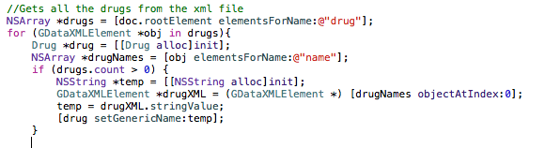

**Figure 4.4** – GData extracting the name variable for the drug object.

The above code in **Figure 4.4** shows how parts of the drug object are read from the XML and stored into an array of drug objects. The GData library finds all the elements in the document object model that match the string and stores all the occurrences of the element in an array. To set all the objects all the root elements are found and stored in an array. For this segment of code “drug” is the root element, the code above finds all the drugs stored in the XML file then for each drug the child elements are found and the string returned that each element holds. Each string can then set the corresponding part of the object for example the name will set the name of the drug object, although some elements contain more than one string meaning arrays of strings were stored. This quite a challenge due to the complexity of the DOM. The drug DOM has many nested elements because of different information stored about adult and paediatric patients.

The need for the XML file to be so complex is due to trying to minimize all the communication with the server to make sure this mobile application can be used offline. Thus it can to be stored in one file that can be sent quickly from the server and stored on the mobile application.

The persistent storage of the XML file once received from the server was another challenge as the as it took time to familiarise with how GData extracted the data from a file. A problem occurred when trying to read from a recently saved file as GData can only process files that are saved in the main bundle of the mobile application as this is the only way to explicitly cast what type the file is. The main bundle is where read only files are stored, not the local directory of the mobile application. The way that this was solved was creating a method in which returns the file path of the main bundle. Once the file was created it could be copied to the main bundle and GData can understand what type of file it is.

///////////////here

Create simple REST server to send a small XML document with dummy data.

Object to XML JAXB

Construct object on server create server.

Client Review.

## 4.3 Iteration 3

Created database MySql,

It had originally been thought that the data for the drugs would be extracted from an already existing database that had been created for the clients website. The database was created using and web hosting service and when the client exported the SQL file it would not open in MySQL or WAMP using various SQL formats. It would open in a text editor but the syntax was confusing and the data was in many tables with various different IDs so would of took much time to find and organise the data extraction manually. This problem was unforeseen in the schedule and time was lost trying to create a solution to use this data.

The Decision was made to create a completely new database rather than using an existing one and editing it to fit the application. This however meant that the schedule had to be changed to allow for design and creation of database. There was an extra two weeks set aside for problems during development so this extra time was used for database design and creation. The design was first done using tables on paper then the tables were created using MySQL’s GUI for Visual Studio. This allowed the tables to be created as they were on paper and allowed for the relationships to be created visually. The SQL then was automatically generated to run on the MySQL server. The main challenge in the database design was getting the relationships to work correctly. The database should be orientated around the drugs table so when a drug is deleted that drugs information is cleared from all the tables in the database. //////HEEEEEEEEEEEEERRREE

Connect database to REST service JDBC database to the object

Return HTML of database

## 4.4 Iteration 4

Admin User Interface

Add/ delete from database

Advanced app features comparing drugs and finding pathogens.

# Evaluation

## .1 Results From User Testing

## .2 Future Work

Add more features to rest server, edit for example. Add different types of drug search feature.

Android.

## .3 Personal Reflection

Report is very hard.

Problems with clients database

Coding went well little problems. Research more frame works instead of reinventing the wheel.

Overestimated the amount of work that could get done in a the time three months sounds like a lot but it really isn’t.

## .4 Client Reflection

Was he satisfied ?

What does he wish happened?

Anything that went badly?

Professionally Managed?

Correspondance

Meeting Notes.

## .5 Dicussion on REST vs the Normal Way vs SOAP

# Bibliography

Android. (2015). *Android, the world's most popular mobile platform*. Retrieved April 13, 2015, from Android Developers: http://developer.android.com/about/index.html

Apple. (2014). *The App Life Cycle*. Retrieved April 25, 2015, from App Programming Guide for IOS: https://developer.apple.com/library/ios/documentation/iPhone/Conceptual/iPhoneOSProgrammingGuide/TheAppLifeCycle/TheAppLifeCycle.html

Apple. (2015a). *About Itunes Connect*. Retrieved April 14, 2015, from IOS Developer Library: https://developer.apple.com/library/ios/documentation/LanguagesUtilities/Conceptual/iTunesConnect_Guide/Chapters/About.html

Apple. (2015b). *XCode Features*. Retrieved April 14, 2015, from Apple Developer: https://developer.apple.com/xcode/features/

Blue Frontier. (2013). *NHS antibiotic guidelines sth*. Retrieved April 24, 2015, from Google Play: https://play.google.com/store/apps/details?id=com.bluefrontier.nhs&hl=en_GB

Bott, E. (2014). *Net Market Share vs. StatCounter: Whose online measurements can you trust?* Retrieved April 13, 2015, from ZdNet: http://www.zdnet.com/article/net-market-share-vs-statcounter-whose-online-measurements-can-you-trust/

Cystic Fibrosis Trust. (2013). *Cross-infection*. Retrieved April 23, 2015, from Cystic Fibrosis: http://cysticfibrosis.org.uk/about-cf/living-with-cystic-fibrosis/cross-infection

Eid, A. (2014). *Apple's Swift is Great, but Objective-C is not Going Anywhere*. Retrieved April 14, 2015, from Huffington Post: http://www.huffingtonpost.com/ahmed-eid/apples-swift-is-great-but_b_5492239.html?

Elkstein, D. M. (2008). *Learn REST: A Tutorial*. Retrieved March 13, 2015, from rest.elkstein.org: http://rest.elkstein.org/

Google. (2015a). *Get Started with Publishing.* Retrieved April 13, 2015, from Android Developers: http://developer.android.com/distribute/googleplay/start.html

Google. (2015b). *Supported Devices.* Retrieved April 13, 2015, from Google Play Support: https://storage.googleapis.com/support-kms-prod/FBD905D8F0C3B7466021873B4B17A7BA6C7F

IMB. (2009). *Build a RESTful Web service using Jersey and Apache Tomcat*. Retrieved April 15, 2015, from IMB: http://www.ibm.com/developerworks/library/wa-aj-tomcat/

MedConnections. (2014). *iPharmacy Pill ID & Drug Info Version 5.8.1*. Retrieved April 24, 2015, from Play Store: https://play.google.com/store/apps/details?id=com.sigmaphone.topmedfree&hl=en

Mills, E. (2012). *Google now scanning Android apps for malware.* Retrieved April 13, 2015, from CNET: http://www.cnet.com/news/google-now-scanning-android-apps-for-malware/

Net Market Share. (2015). *Market Share Reports.* Retrieved April 13, 2015, from Net Market Share: http://marketshare.hitslink.com/

Quotient Integrated Solutions. (2014). *Benefits of Agile: Increased Customer Collaboration*. Retrieved April 9, 2015, from Quotient: http://quotient.net/

Shiny Development. (2015). *Average App Store Review Times*. Retrieved April 14, 2015, from Average App Store Review Times: http://appreviewtimes.com/

StatsCounter. (2015a). *StatsCounter Global Stats World Wide.* Retrieved April 13, 2015, from StasCounter Global Stats: http://gs.statcounter.com/#mobile+tablet-os-ww-yearly-2015-2015-bar

StatsCounter. (2015b). *StatsCounter Global Stats For GB.* Retrieved April 13, 2015, from StatsCounter Global Stats: http://gs.statcounter.com/#mobile+tablet-os-GB-yearly-2015-2015-bar

The Agile Alliance. (2015). *The Twelve Principles of Agile Software*. Retrieved April 3, 2015, from Agile Alliance: http://www.agilealliance.org/

Vogel, L. (2014). *REST With Java (JAX-RS) Using Jersey - Tutorial*. Retrieved March 13, 2015, from www.Vogella.com: http://www.vogella.com/tutorials/REST/article.html

# Appendix A External Materials

## A.1 First Iteration User Interface

A.1.1 Drug Table View A.1.2 Drug Detail View A.1.3 Pathogen Table View

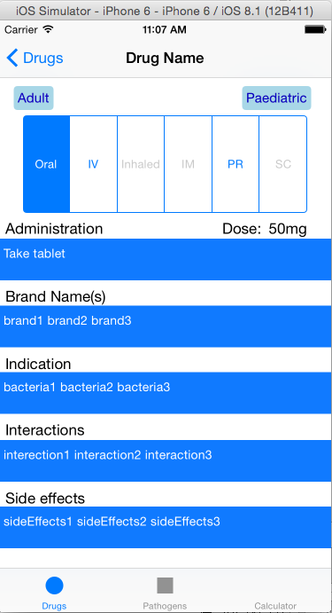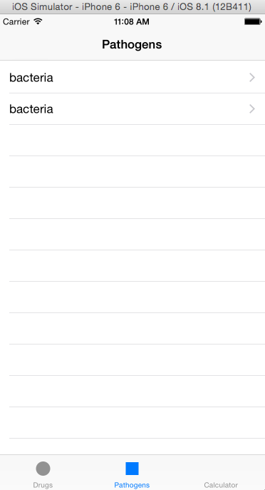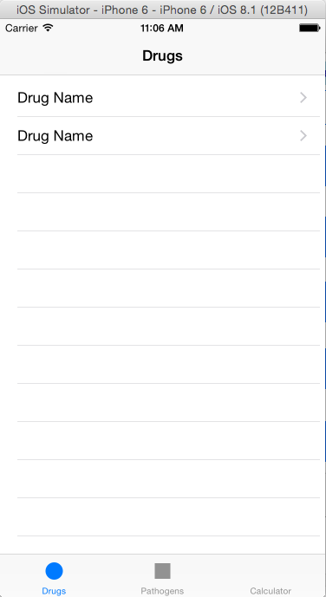

A.1.4 Pathogen Detail View A.1.5 Calculator View

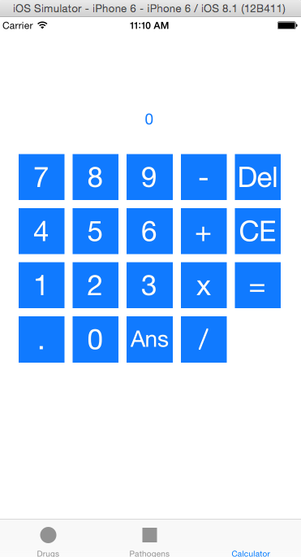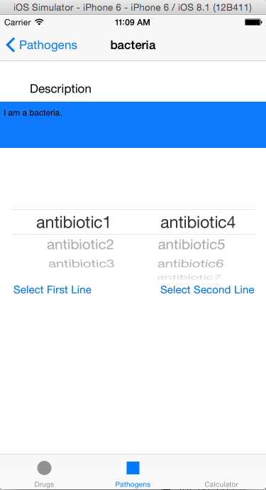

## A.2 Meeting Notes

### A.2.1 Meeting 1 Introductions

The first meeting about the project allowed the client, my supervisor and I to meet each other and get some overall requirements for the project. The main requirements for the application as specified by the client was:

* Clarified the problem of information about antibiotic medicine is hard to find quickly when in places like hospitals with poor signal and no internet connection. App needs to work offline and easy to access.
* IOS application preferred but both IOS and Android wanted.
* Colour coded to easily refer to the pathogens and activity codes.
* Would like a disclaimer at the start.
* Suggestions on what antibiotics to use and what are dangerous in combination.
* Emphasis on visual warnings such as red to indicate bad combinations.

Other various interface design and database structures were discussed with supervisor. A site created for this purpose was looked at for some information on the subject.

### A.2.2 Meeting 2 Refining Requirements

The second meeting the interface I designed was commented on and refined to suit the client. Changes were made such as navigating on the pathogen and drug view to have a more segmented interface rather than all the information on one view. A colour coded side bar was added and a tabbed heading navigation was added to the top of the view. Also an extra feature was discussed to be able to test your selection of antibiotics to see if there are any issues such as needing to check kidney function when using a certain combination of drugs. The image below is the process of selecting features from the paper design that were liked and possible changes that could be made, this was done with the client during the meeting.

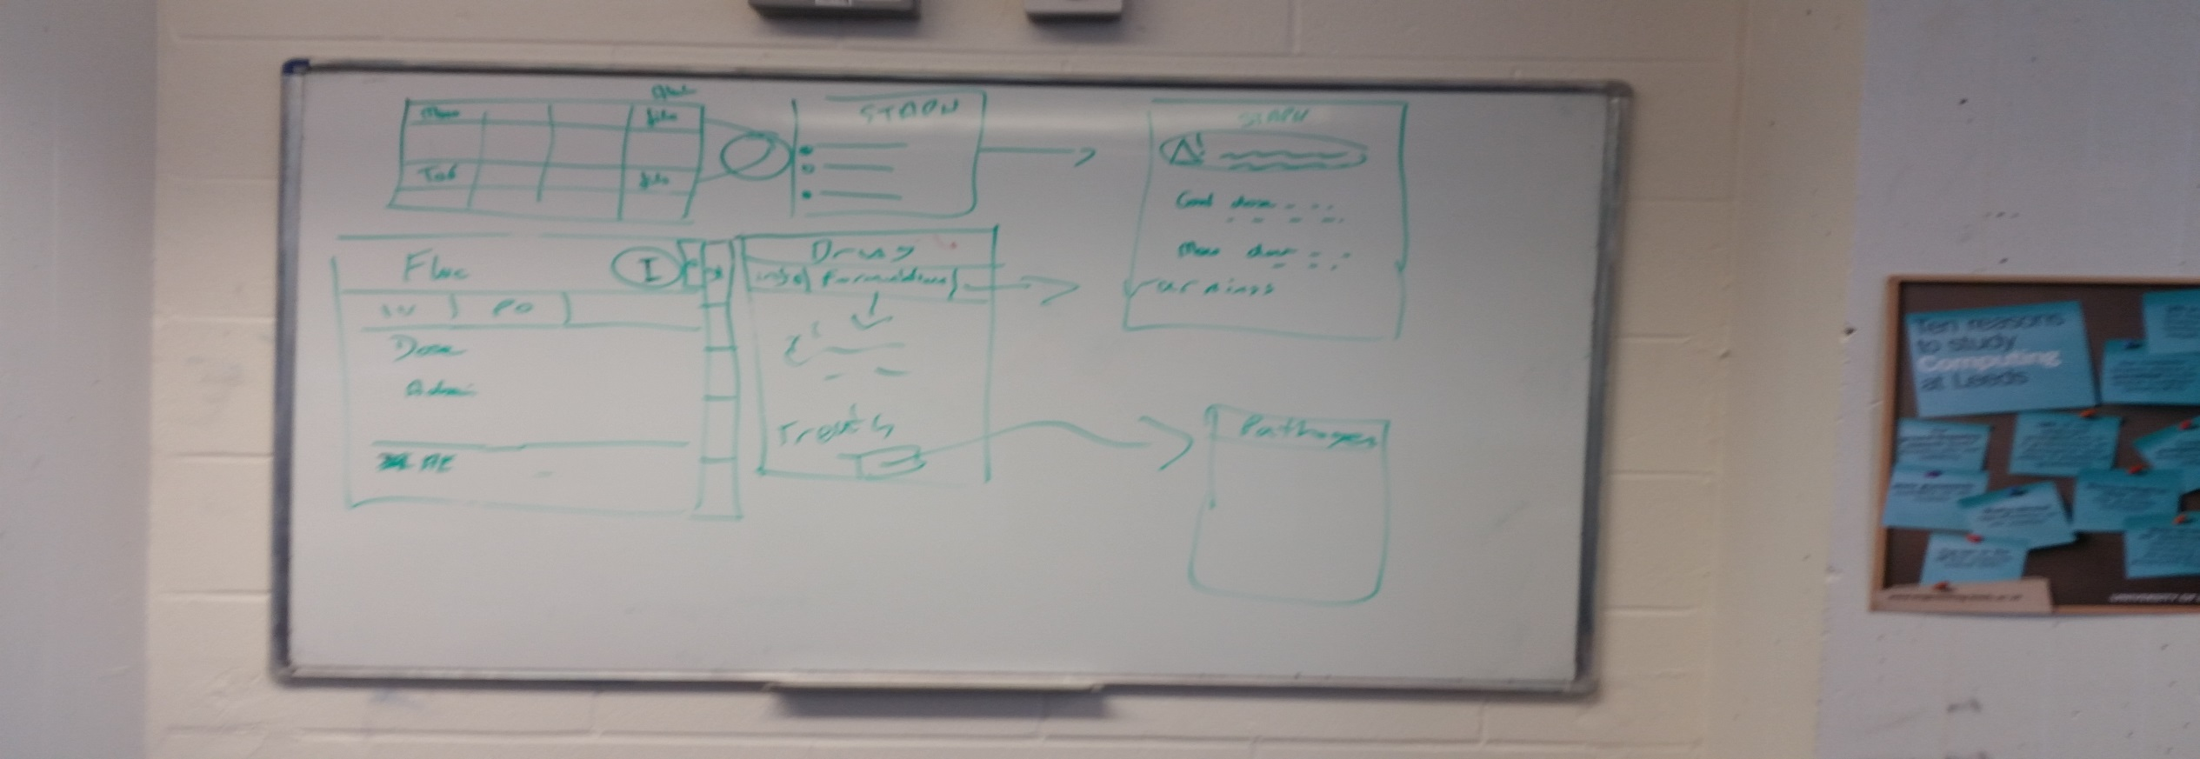

### A.2.3 Meeting 3 Data structure

This was a shorter meeting about structure of the drug and pathogen objects. The fields of each object was discussed to make sure I had the correct idea and the client made me a help sheet to know what each drug and pathogen should have about them. The database structure was also discussed but agreed that this should be though about and implemented in the second iteration and just to get the mobile app running first. A deadline was set to have a working version of the mobile app by the 24th of February.

### A.2.4 Meeting 4 Presentation of First Iteration

I showed the app to my client in meeting room 715 with my supervisor in the SoC reception. The client was very impressed and offered some constructive criticism on the interface and the operation. The main points were:

* The ordering of which fields appeared on the drug detail view of the app.
* It should be more obvious if it is for adult or paediatric.
* Colour scheme was liked but few changes wanted such as no turquoise.
* The dose is not a number but a block of text so needs a field not a label.
* Titles like “treatment for” should be replaced with more standard medical terminology like “indications”.
* A search feature would be really helpful to be able to search for brand names of a drug if you didn’t know the generic name.
* First and second line drugs should be less structured so one column on the picker is best, to prevent arguments between different experts, instead of two.
* A pathogen spectrum button should be added as the indications should be a block of text not a list of the pathogens. So I suggested that the button will take you to another view with a list of the pathogens which was agreed.
* The originally intended ability to embed links into the text has been decided not to be implemented as having lots of links in a small block of text may lead to users pressing them by accident causing frustration. All the information will be accessed by the navigation already provided as well as a few buttons here and there.
* Calculator works fine no changes needed.

### A.2.5 Meeting 5 Presentation of Second Iteration

During this meeting the database was discussed and where the server is going to be hosted. One option is to use a web hosting company but I am not sure if I can deploy my war file to this. The interface was discussed again and the colours are going to be changed to something less vibrant and make sure the buttons are a different colour to the text boxes to avoid confusion.

### A.2.6 Meeting 6 Presentation of Third Iteration

The changes to the interface was shown and really went down well. No further changes are needed to the interface of the App. The server administration and database were presented. There was a discussion of how they worked and the client was impressed and is considering using the website as a main source to getting the drug information rather than his website but this would require doing more work outside of the scope for the project and may be taken on after. Some suggestions were made to the final features of the app such as what to be displayed for the comparisons. It was discussed if there is some extra time in the schedule that some features could be added to the admin interface:

* Sorting, searching, and filtering to the display tables of the data as HTML.
* The first line drugs could be a drop down of existing drugs in the database rather than adding names of drugs. This will avoid the chance of causing errors with the interaction feature.
* The linking between data in tables was also discussed it was suggested that the pathogens could have relationships to the drugs.

Final deployment was discussed and hosting options were looked at but still no solid choice yet as I still need experience in this area. The future of this project was discussed and possible features that could be added after the project is handed in to the University such as the ability of drug types and hosting the NHS database of drugs.

## A.2.7 Meeting 7 Presentation of the forth iteration

This meeting the last features were shown:

* The feature to show the pathogens associated with a drug.
* The feature to show drug interactions when selected from a list to treat a pathogen.
* Sorting on the html tables.

During the meeting the hosting service was chosen we decided to go for mochahost business plan for one year. The features were well liked by the client but the feature to edit the fields of the database using the REST servlet interface might not have time to be implemented as time is needed for finalizing the report. This wasn’t a must have feature more like a should have but I don’t know if it is possible in the time frame as the PUT request is the hardest to implement in my opinion. The client would really like the feature implemented if possible and it will be done if I have time. The client also mentioned it would be nice to have custom icons for the tabs on the navigation bar. But due to time constraints there will probably be little more development and this is understood. One bug was found during testing in the demo where array was not getting deleted after use in the pathogen detail view. I corrected this during the meeting the app is now known to have no bugs and is ready for deployment.

A presentation/testing is scheduled in two weeks where I will present the application to the clients colleagues and have them test the application. A simple semi-structured user evaluation will be created for this purpose.

## A.3 Second Iteration User Interface

A.3.1 Disclaimer View A.3.2 Drug Table View A.3.3 Drug Detail View

(expanded Scroll)

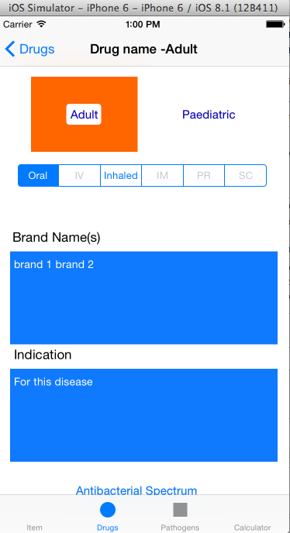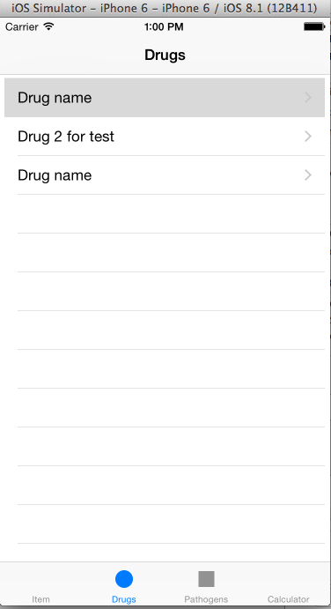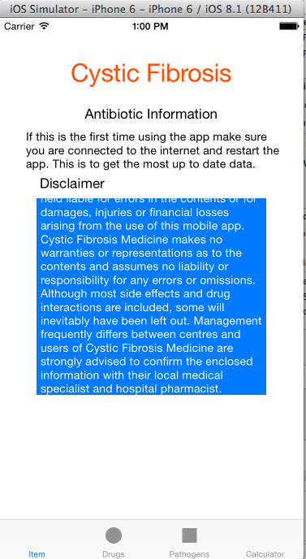

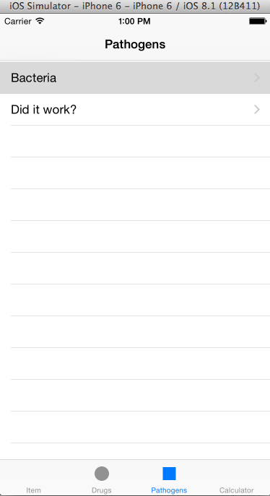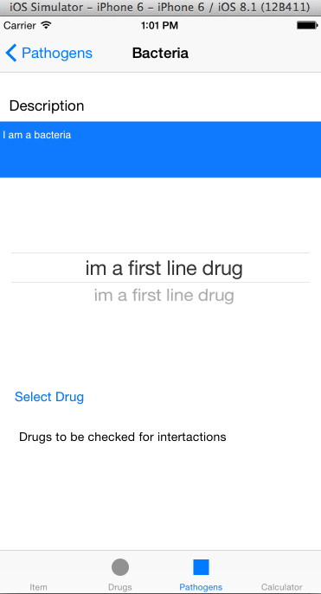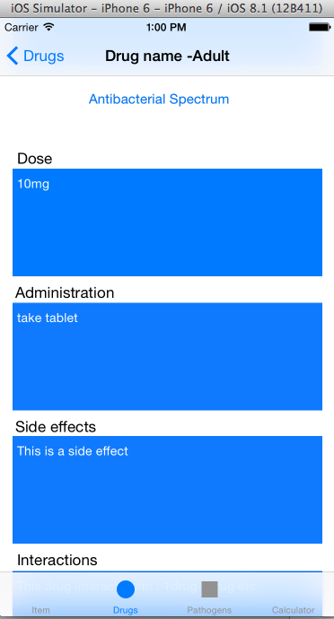A.3.4 Pathogen Table View A.3.5 Pathogen Detail View

## A.5 User Stories

|  |  |
| --- | --- |
| User Story | Features |
| As a user, I want to be able to use this application offline, but receive updates when online. | 1. Create a method that can receive data from an online source and store it locally on the mobile application. The data should then be converted into objects that can be used to hold this data. |
| 2. Create a method that will check for an update when the application is connected to the internet. |
| 3. Create a server to send data over the internet to the application. |
| 4. Create or use existing database to store this data and allow the server to manipulate this data. |
| As a user, I want to be able to select from list of drugs or pathogens to gain further information. | 1. Create a suitable feature in the user interface to display a list that can be selected to show detailed information. |
| As a user, I want to be able to see the required information about a drug at a glance. This includes; a name, brand names, dose, type of drug, interactions, side effects and various routes of administration for paediatric and adult patients. | 1. Create an object that can hold this information about a drug. |
| 2. Create a suitable feature in the user interface where all the fields for a drug can be shown and changed when different options are selected. |
| As a user, I want to be able to see information about a pathogen. This should be the name description and drugs that can treat this pathogen. | 1. Create a pathogen object to hold this information. |
| 2.Create a suitable feature in the user interface where all the fields for a pathogen can be displayed. |
| As a admin, I want to be able to add new drugs or delete outdated ones. The admin should be able to do this with little computing knowledge. | 1. Create an administration interface that allows editing of the database that is simple and accessible by users unfamiliar with databases. |
| As a user, I want to be able to check for interactions between drugs that treat a particular pathogen. | 1. Create a feature where the user can select a pathogen see a list of drugs. The user should be able to then select these drugs and see if there are any interactions. |
| As a user, I want to be able to see all pathogens that a particular drug treats. | 1. Create a feature when viewing a drug to see all the pathogens that are affected by it. |

First Iteration: Second Iteration: Third Iteration: Forth Iteration:

## A.6 Document Object Model Tree for XML File

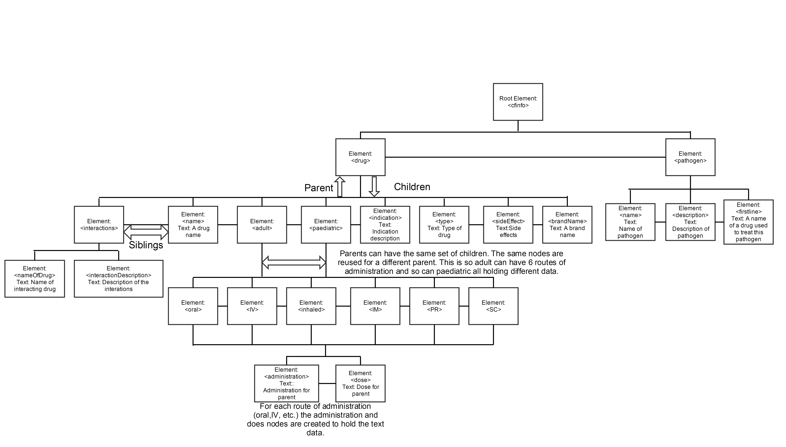

# Appendix B Ethical Issues Addressed

## B.1 Level 2 Heading